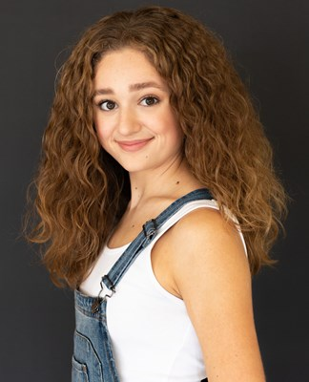

Alyssa Hurtado

Hair color: Light brown Eye color: Hazel Voice Type: Mezzo Soprano

[alyssabhurtado@gmail.com](mailto:alyssabhurtado@gmail.com) (512)922-5088

**Theatre**

ARCADIA Thomasina Coverly Austin Playhouse/Lara Toner Haddock

MOTHER OF THE MAID Joan Arc Jarrott Productions/David Jarrott

MALA HIERBA Fabiola TXST/Jessica Fiene

WHEN THOU WAKEST Hermia TXST/Nick Lawson

CEBOLLAS Play Reading Yolie BLPC @ TXST/Jerry Ruiz

PICNIC Millie Owens Zach North/Stephanie Smith

THE WIZARD OF OZ Dorothy Gale RRHS/Johanna Whitmore

BRIGHT STAR Margo Crawford RRHS/Johanna Whitmore

**Commercial/Film**

HOW TO MUSICAL THEATRE Reynolds Allen Robertson/Damon Brown

SCOUT - SSA Musical Movie Nikki Allen Robertson/Damon Brown

DELL/BLUE INSPIRON Gen Z Friend Beth Sepko

ACE IT - SaulPaul Music Video Teen Ashton Rodger Woodruff

MOON-CALF Olivia Ander Echeverria

**Training/Experience**

Acting Training: Texas State University BFA Acting Major (Most recently: Physicalization with Micheal Costello, Movement with Nadine Mozon and Dialects with Kate Glasheen-Dentino), Zach North Acting Conservatory, Write, Shoot, Direct camp (Zach Theatre), RRHS Musical Theatre I-IV and Production I-IV

Voice Training: Private vocal lessons from Dr. Ellie Shattles, Rose Yurcina, Classical voice class Sarah Stokes, Long Center Select Ensemble directed by Ginger Morris

Dance Training: TXST Dance Minor, three years drill/dance team experience,The Dance Works studio classes- jazz, contemporary, ballet, leaps and turns, drill team

**SPECIAL SKILLS/INTERESTS**

Lifeguard/CPR Certified, drill team experience (kick lines, precision dance), five years competitive swimming, two years cheerleading, two years American Sign Language courses, novice guitar player, beginner improvisation skills