AREAS OF EXPERTISE

*Voiceovers*

*Theatre movement*

PERSONAL DETAILS

*Height;* *5ft 4 inches*

*Weight;* *135 lbs*

*Build;* *Athletic*

*Eyes;* *Brown*

*Hair;* *Dark Brown*

*Role ages;* *22 – 30*

CONTACT DETAILS

*Lala Guerrero*

*Austin, Texas*

1. *512-400-9867*

[*guerrerolala92@gmail.com*](mailto:guerrerolala92@gmail.com)

*Driving license: Yes*

STUDIED UNDER

*Cold Towne Improv*

*Laurel Vouray - In the Moment Acting - 2023*

*Maurice Moore - Breath Studio - 2022 -2023*

*Elizabeth Reeder - Studio E – 2008- 2010*

*Carol Hickey- Current*

*REFERENCES – Available Upon Request*

**ACADEMIC ACHIEVMENTS**

**Texas State University**

Integrative Studies Major

Theater Arts Minor w/ Emphasis in Film

**Austin Community College**

Associates- Spanish

Lala Guerrero

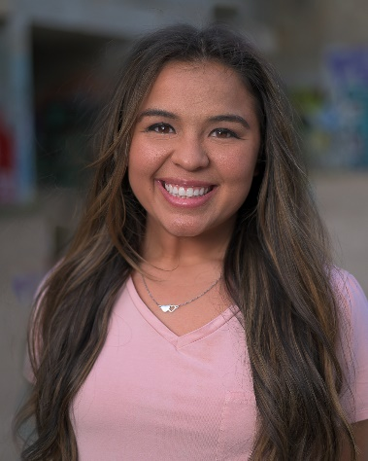

Acting Resume

PERSONAL SUMMARY

A motivated, committed and talented actress with strong stage and film instincts and extensive formal training. Lala is a perfectionist who possesses a solid work ethic. She is committed to achieving the highest standard of performance and is always willing to listen and learn from others. She is energetic, prepared to 'go the extra mile' and is sure to make a real difference to any project she is involved in.

CREDITS

|  |  |  |  |
| --- | --- | --- | --- |
| ***Film*** | | ***Name*** | ***Character*** |
| • | 8lien Arts | Miscellaneous Thom | Perry (Lead) – 2024* |
| • | Rosenburg Productions | Sex Rules | Genysis (Lead) - 2024 |
| • | Drammadox Pictures | Wishing on Stars | Mo (Supporting) - 2024 |
|  | 48 Hour Film Festival | Bang! Bang! Bang! | Liv (Lead) - 2023 |
|  | ACC Student Film | Bank Man Fraud | Sarah (Supporting) - 2023 |
|  | UT Student Film | Conversation with Friends | Bobbi (Lead) - 2023 |
|  | ACC Student Film | Love Lost | Ana (Supporting) - 2023 |
|  | Hell Bus Entertainment | Lullaby | Lala (Lead) - 2024 |
|  | DMP Productions | The Thunder and The Moon | Luna (Lead) - 2023 |
|  | Bamford Films | Parable | Evelyn (Lead) - 2023 |
| ***Television*** | |  |  |
| • | Randy Roger’s Band Music Video | I Won’t Give Up | Lead Dancer- 2024 |
|  | * Matt “The Cat” Hillyer Music Video | If I Didn’t Have You | Lead Dancer- 2024 |
|  | * Los Lonely Boys Music Video | Send More Love | Featured Extra- 2023 |
|  | ***Commercial*** |  |  |
|  | * Rocketfuel Productions | GAMMA Sports Commercial | Pickleball Player - 2023 |
|  | * Bad Walrus | Dean Boyd Law | Hit and Run Victim- 2023 |
|  | * Bad Walrus | Dean Boyd Law | Wife -2023 |
|  |  |  |  |
|  |  |  |  |

KEY SKILLS AND COMPETENCIES

* Stunt Certification - Level 1
* Stunt Certification - Level 2
* Wire Working – Level 1
* Country Westen Two Step
* Modeling
* Horseback Riding
* Improv

*Nominated for Best Actress